QUE_1
1. - use a command to show the current working directory
- list the directory contents in the short and long format
- list all files along with hidden files in the current working directory.
- list only hidden files in the directory
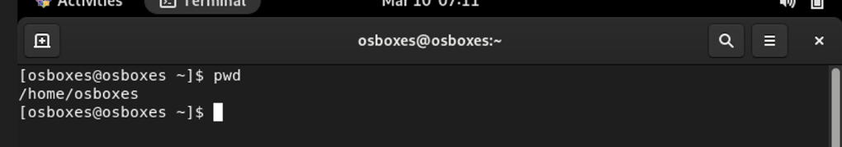
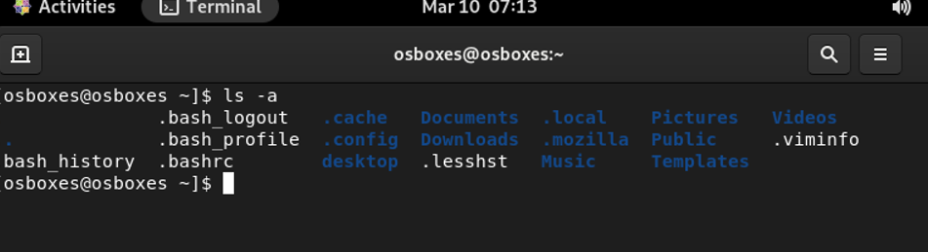
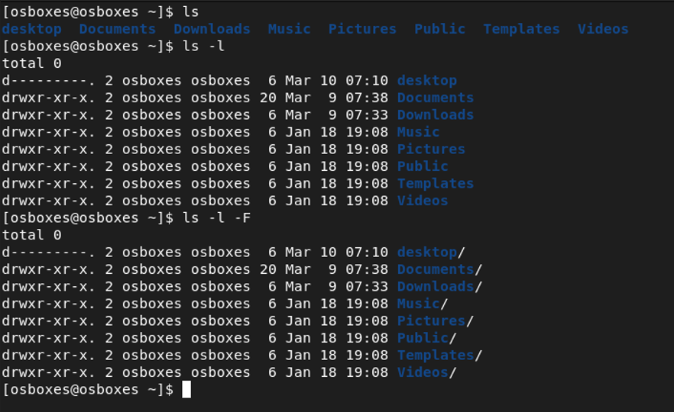
2. Make a directory and name it as cdac-dir and change the current working directory to the new directory.
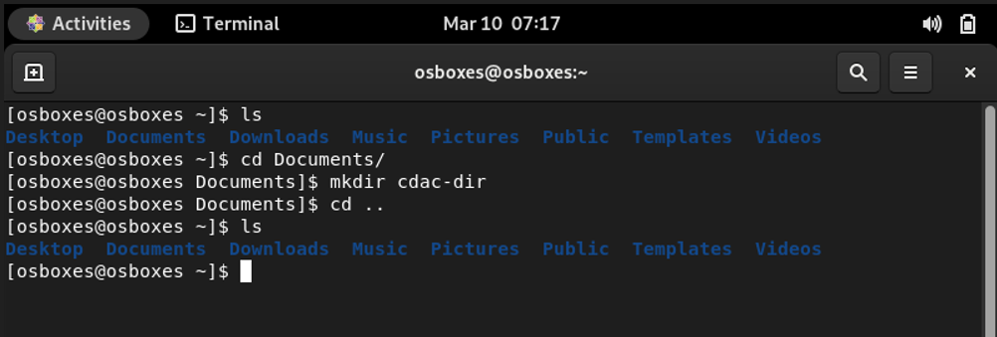
3. List the directories(folders), then remove the cdac-dir directory and list the folders again to show that it is no longer present
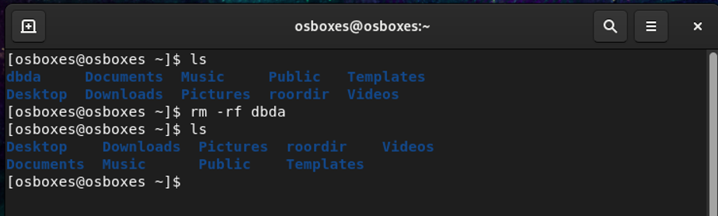
4. Make a directory and name it as cdac-dir and change the current working directory to the new directory.(Hint : use mkdir,cd commands)

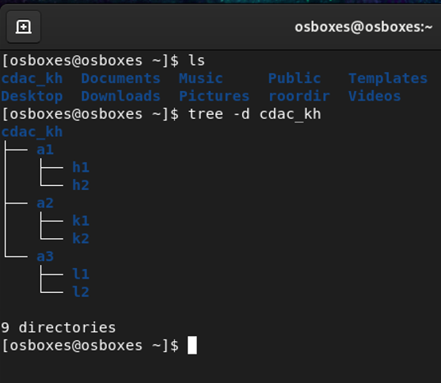
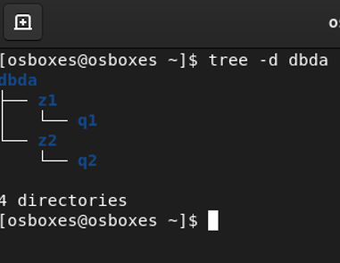

QUE_2
1. Display the man-page for ls, but redirect the output into temp.txt, then use the cat, less, and more commands to display the new file.

[osboxes@osboxes ~]$ man ls >>kp.txt
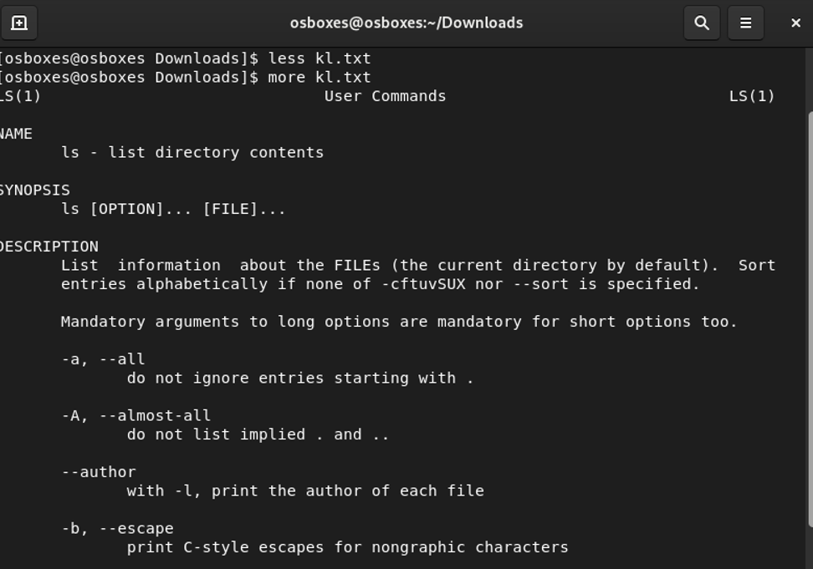

2. Display the initial 10 lines and final 5 lines of temp.txt with the obvious Linux commands.
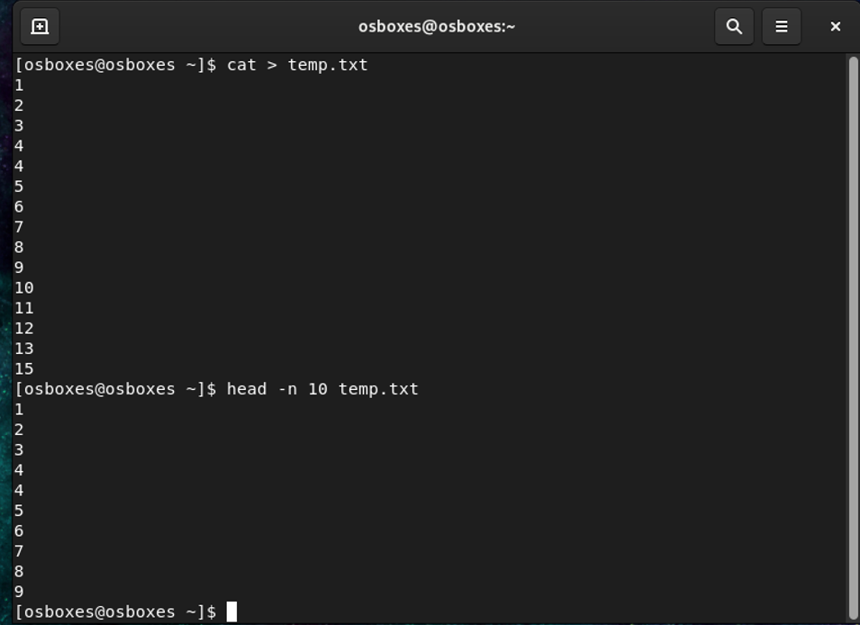
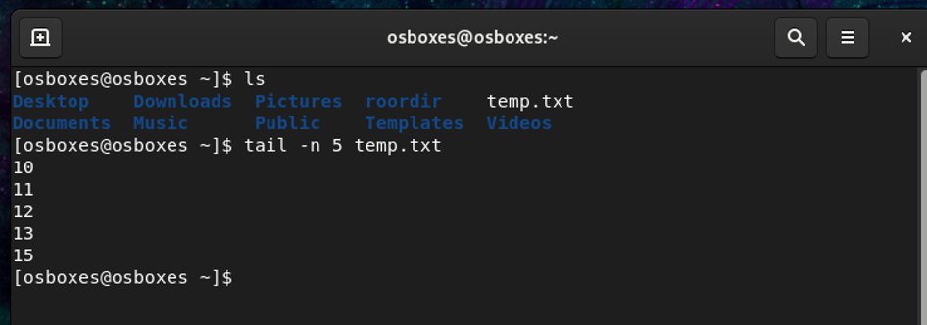

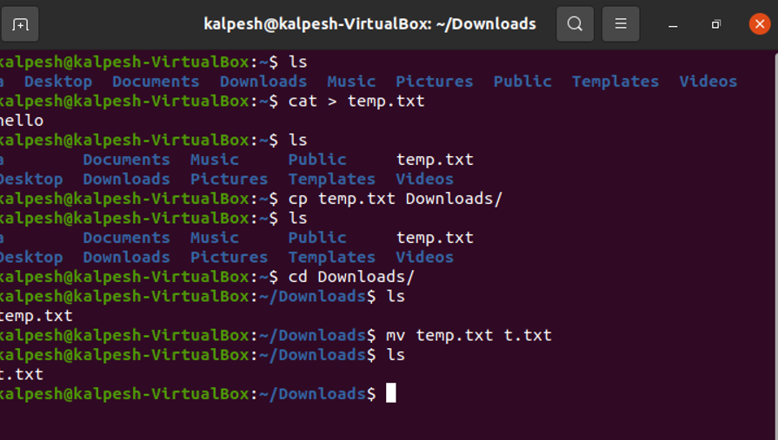
3. Copy temp.txt to the directory and rename it there.
4. Display the number of lines, words and characters in file using Linux
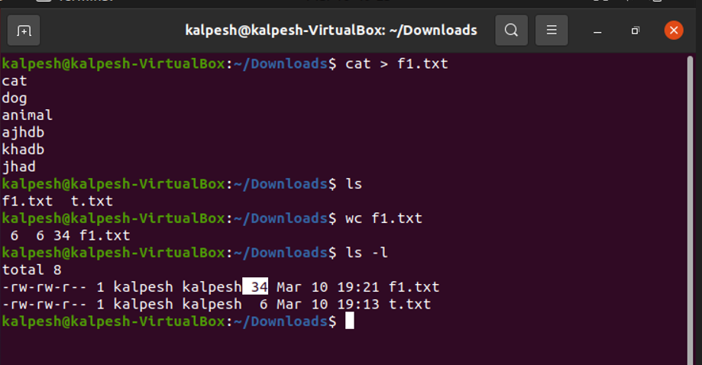
5. Use history command to display last 10 commands used.

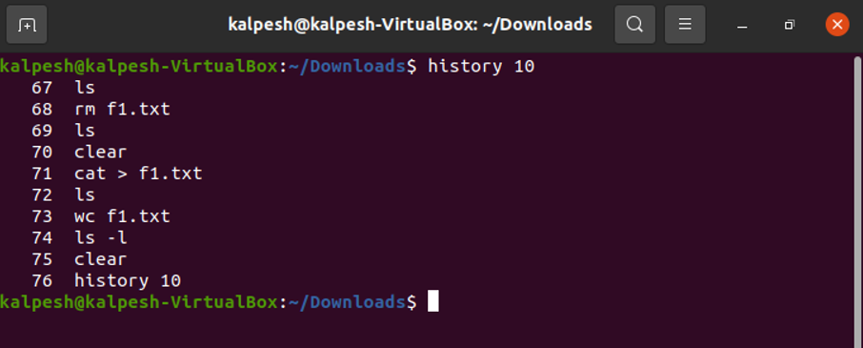

Question-3.

1. Create tar archive file of any directory present in your home directory.
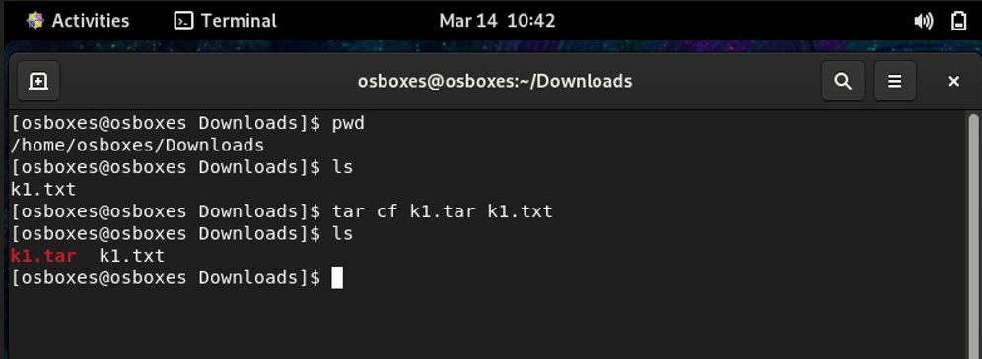

2.Create zip file of another directory. (Hint: use zip command)
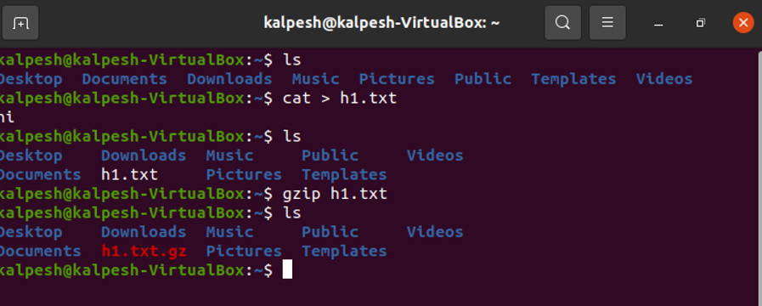
3. Give read, write & execute permissions to your file.
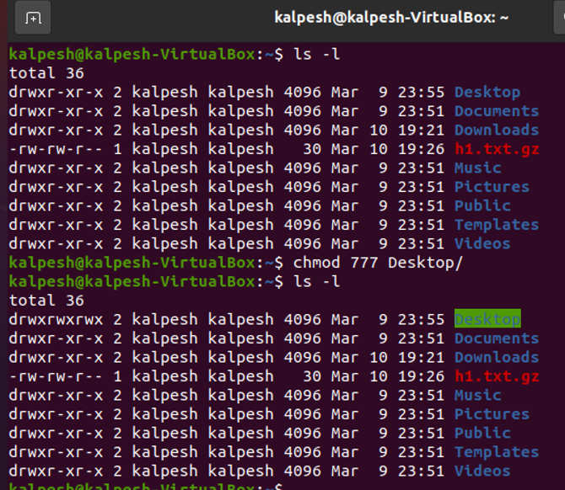

4. Change ownership of that file.(Hint: use chown command)

5. List processes running in shell, all running processes
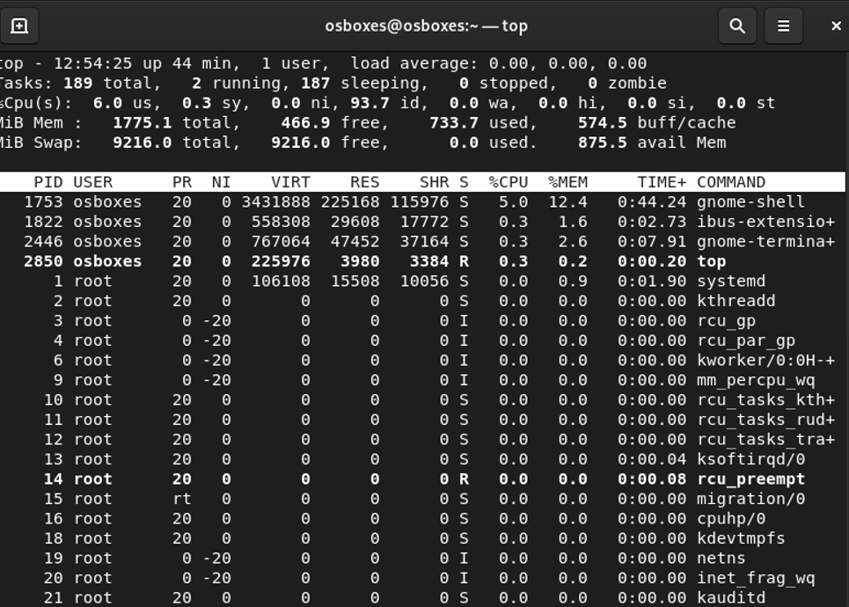
Question-4.

1. Display current time and calendar

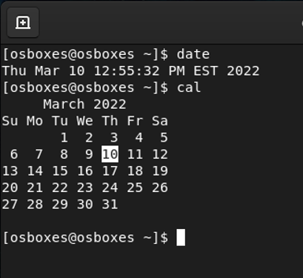

2. Change the current date and time of the system to following 14th March 2017, 10:10 AM

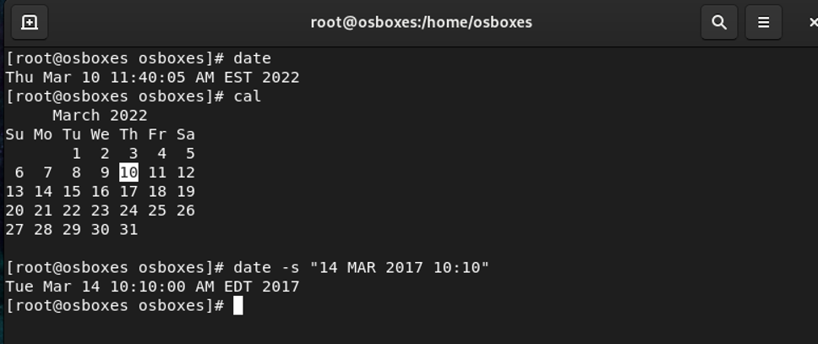
3. Explore following commands who, whoami, whatis, whereis

[osboxes@osboxes ~]$/home/kp1# whoami
root
[osboxes@osboxes ~]$/home/kp1# whatis ls
ls (1) - list directory contents
[osboxes@osboxes ~]$/home/kp1# whereis kp2.txt
file: /usr/bin/file /usr/lib/file /usr/share/file /usr/share/man/man1/kp2.gz

